**COSC364**

**RIP Routing Assignment**

**Team: Drogo Shi () & Haider Saeed (msa280)**

**Drogo Shi (50 %):**

**Parts done:**

* **Created Router() class which handles the functionality of a router.**
* **Implemented the creation, sending, and testing of packets.**
* **Implemented timers and their related functions.**
* **Implemented split horizon with poisoned reverse.**
* **Completed metric handling including the changing of metric with triggered updates.**
* **Created route handling and dealing with dead routers.**

**Haider Saeed (50 %):**

**Parts done:**

* **Created Configure() class which reads and sorts data from the configuration file.**
* **Created different configuration file test cases.**
* **Created and designed the printing of the routing table.**
* **Did commenting and cleaned code.**
* **Created the report and documentation.**
* **Implemented testing including socket receiving, binding, and sending functions.**

**Question 1) Which aspects of your overall program (design or implementation) do you**

**consider particularly well done?**

To create the code, we had to treat the configuration file and the router separately. Therefore, the ‘Congifure’ class was made to only deal with the configuration files whereas the ‘Router’ class was made to deal with the routers and its related functions. To ensure code cleanliness and readability, creating these two classes was important. The design of the routing table is also clean, easy to read and informative. The actual functionality of the router works in the way it is supposed to. Any wrong packets are discarded, and any dead routers are deleted after their respective timers run out. The timers work well and seem to stop after they have reached their timer limit. All the fields in the routing table show accurate next hops and metrics along with their correct router ids. In the configure class, a lot of test cases were added to handle incorrect configuration files. These have many test cases like verifying the format and checking for mandatory fields before proceeding to creation and binding of sockets. If anything goes wrong, a detailed message is given to show what went wrong in the program.

**Question 2) Which aspects of your overall program (design or implementation) could be**

**improved?**

Having a separated timer class could improve the design of the project. It would also improve code readability and separate the timers from the routers. The design of the program could be improved so that if we need to change parts of our program in the future, it can be easily done. This will also allow us to handle any errors separately according to their respective classes.

**Question 3) How have you ensured atomicity of event processing?**

The atomicity of event processing was ensured in a few ways. For example, the garbage timer only works if the timeout timer runs out. Separation of the two timer functions ensures that if one is being called, the other won’t occur. The sending and receiving of packets were also done separately. This meant that if the router was receiving packets, it wouldn’t interfere with the sending of the packets.

**Question 4) Have you identified any weaknesses of the RIP routing protocol?**

The RIP Routing protocol has a couple of weaknesses. One of the major drawbacks of the RIP protocol is that it has maximum hop count of 15. This means that it won’t reach router farther 15 hops and will change to 16 which represents that a destination is unreachable. This makes RIP good for small networks but not so useful for larger networks.

The metrics in RIP cannot be changed and always remain static therefore, if any route metric is required to be changed, the configuration files must be manipulated instead and thus makes the RIP protocol incapable of being used in real time applications where the metrics are constantly changing.

RIP also allows the use of count of infinity where it changes the metric to 16 by incrementing 1 each time. However, this is not very useful as in some cases, the routing loops can carry on for a long time.

Also, if a router goes down in RIP, other routers must wait for a routing update before they know that a router is dead. This can take a while to calculate any alternative routes.

**Testing**

The testing section is also divided into two parts. The first part of the testing has to do with the configuration files themselves. These are the things being tested in each of the test configuration files. The results will give a detailed explanation on what went wrong with the configuration file during reading. These tests also check if the values of the metric, router ids, input and output port numbers are all accurate and lie within their allowed ranges. The tests also check for any missing mandatory field or values.

id_test1.txt - tests if router id < 1

id_test2.txt - tests if router id > 64000

ip_test1.txt - tests if input port is negative

ip_test2.txt - tests input port >= 1024

ip_test3.txt - tests input port <= 64000

ip_test4.txt - tests if all entries are not in one line

ip_test5.txt - tests if an input port is repeated

op_test1.txt - tests if output port number >= 1024

op_test2.txt - tests if output port number <= 64000

op_test3.txt - tests if output metric number >= 1

op_test4.txt - tests if output metric number <= 15

op_test5.txt - tests if output router id >= 1

op_test6.txt - tests if output router id <= 64000

op_test7.txt - tests to see if an output port number is in input port number

op_test8.txt - tests to see if all output port numbers are on one line

format_test1.txt - tests if missing router id parameter

format_test2.txt - tests if missing input port parameter

format_test3.txt - tests missing output port parameter

config_test1.txt - tests missing router id value

config_test2.txt - tests missing input ports values

config_test3.txt - tests missing output ports values

These tests therefore show that no matter what type of config files is given to the routing protocol, it will never begin execution until all its conditions are met. Instead, an error message will be shown showing what went wrong with the configuration file. This helps verify that all the router details including ids, metric, port numbers and other parameters line up with the requirements before proceeding.

The second part of the testing sections tests the functionality of the routing protocol which includes packet creation, packet correctness, split horizon with poisoned reverse, triggered updates, timers, and routing table correctness. A packet testing function is developed which tests incoming packets for incorrectness and returns an error message with the part of the packet that failed the check. The packet creation functions match the criteria for creating a new RIP packet with all their respective initial fields and values. If a packet is incorrect, it is dropped.

**Functionality Tests**

When a router is started, it is supposed to create and bind to all the sockets. Then an empty table should be printed. This is because no other routers are alive yet. The router should try to send packets as well. This is shown below.

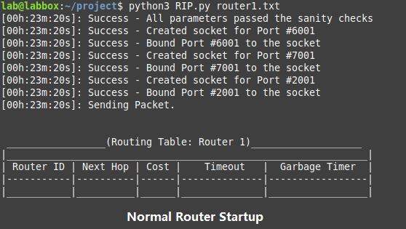

If a router is already alive, we get an error message that tells us that the port’s binding to socket was unsuccessful because the address is already in use. Example:

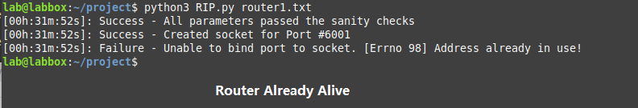

Once we start up router 2, we expect router 1 and router 2 to find each other and add each other to their routing table while updating the cost of that path and a respective timeout timer should also be started for both the routers. A link between the two routers is formed like this and the cost of this link should be 1.

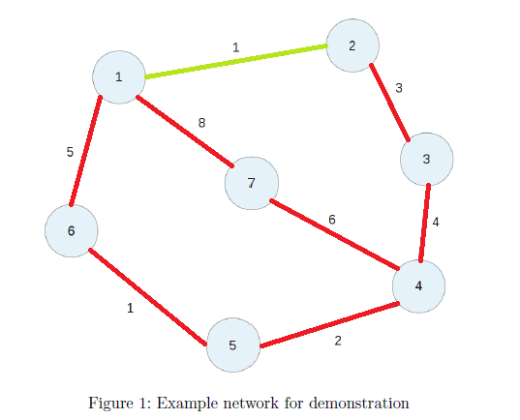

This is exactly what happens when Router 1 finds Router 2. The cost of Router 1 is ‘1’ and the timeout has started. To reach Router 2, the next hop is 2 which is correct. The garbage timer is still 0 as timeout timer hasn’t expired yet. Example:

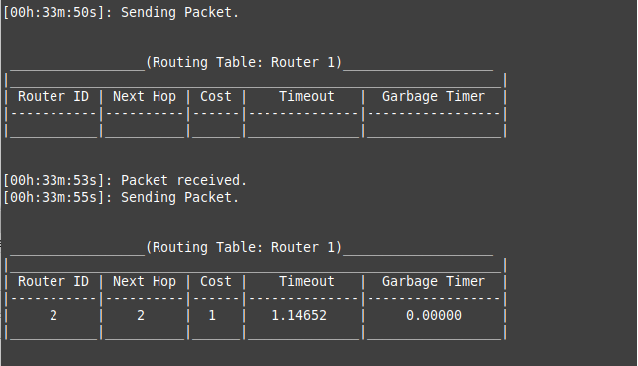

As seen in the above image, Router 2 also reacts in the same way and starts its own timeout timer. The cost and next hop are ‘1’ and 1 respectively. This is correct and both routers have established an adjacency between them. They are also both sending and receiving packets to and from each other.

**Split Horizon with Poisoned Reverse**

Next, we shut down Router 2. The expected results are change in the metric from Router 1 to Router 2 which become 16. This is because 16 represents that Router 2 is now unreachable. In the background, the timeout timer is also supposed to run out and a garbage timer is then expected to start where after the completion of the garbage timer, Router 2 is deleted from the routing table of Router 1. This is shown step by step below:

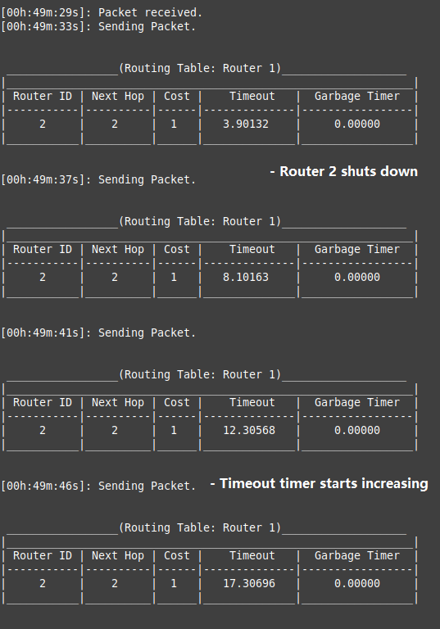

After Router 2 shuts down, Router 2’s timeout timer starts increasing. Router 1 now again keeps sending a packet but doesn’t receive any from Router 2.

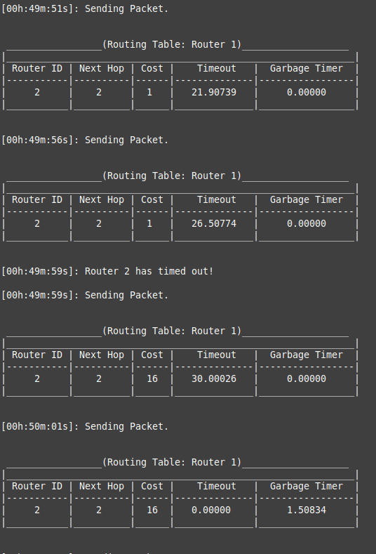

After not receiving any response from Router 2 for the set amount of timeout time, Router 2 will be timed out and its timeout timer will reset to 0. The cost to Router 2 will change to 16 making it unreachable and the garbage timer for the router will start.

After the garbage timer runs out, it is expected that Router 1 removes Router 2 from its routing table. Router 1 table becomes empty again as it knows that Router 2 is dead. This is precisely what goes down as seen in this example snippet:

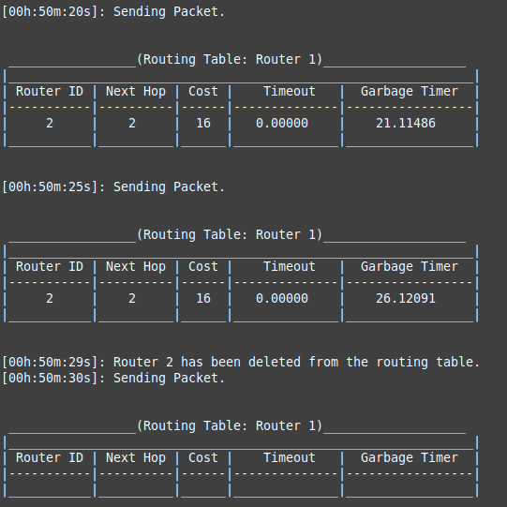

**Convergence test for all the routers.**

Now, we start up all the routers to see if the routes converge as expected. The routing table will then show the shortest path to reach each router. We will take Router 1 as an example for this scenario.

The expected shortest path from Router 1 to:

Router 2 – (Next Hop = 2, Cost = 1)

Router 3 – (Next Hop = 2, Cost = 4)

Router 4 – (Next Hop = 2, Cost = 8)

Router 5 – (Next Hop = 2, Cost = 10)

Router 6 – (Next Hop = 6, Cost = 5)

Router 7 – (Next Hope = 7, Cost = 8)

Let’s start up Router 1, 2, 3, 4 and 7. This is what the connected map should look like.

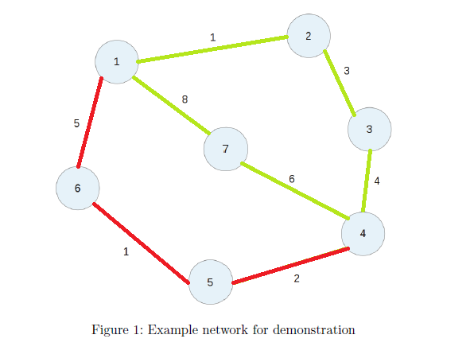,

Once the following routes are developed, we see the following routing table for Router 1.

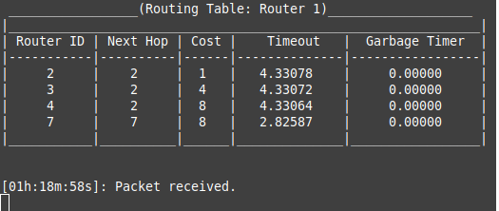

Here we see another very important thing. Router 1 chooses to go to Router 4 through Router 2 and 3 rather than Router 7. This is because through Router 2 and 3, a shorter path is offered. This means that the route calculation is working well and only the correct metric and next hops are being identified. If we turn off Router 2, the link from Router 1 to Router 4 through Router 2 will be broken. The link from Router 1 to Router 3 will also be broken This will force Router 1 to find a new shortest path to Router 4. This means it will then go through Router 7. Our results show this once Router 2 goes down:

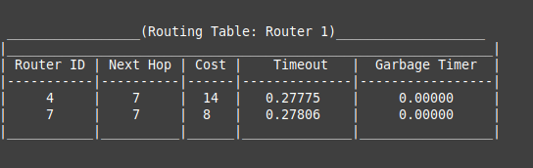

Here we see that Router 1 no longer has a route to Router 2 or Router 3. Router 2 got deleted so of course Router 1 can’t find that router. As for Router 3, there is another path available which is through Router 7 and Router 4. However, the total cost of this path is 18 and RIP V2 only allows a maximum of 15 hops. Therefore, Router 3 also gets deleted. As for a path to Router 4, Router 1 now finds a new path which is through Router 7. Therefore, it updates its next hop to 7 and changes its metric to 14 which is correct. This is a good example to show both triggered updates and poisoned reverse. The following is the routing table for Router 1 after all other Routers are on and the table has converged.

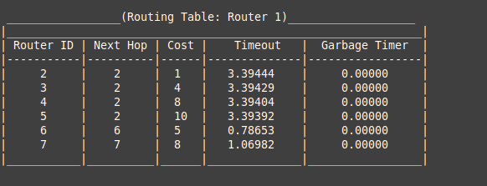

If we look back, it matches perfectly with our predicted outcome which was:

“The expected shortest path from Router 1 to:

Router 2 – (Next Hop = 2, Cost = 1)

Router 3 – (Next Hop = 2, Cost = 4)

Router 4 – (Next Hop = 2, Cost = 8)

Router 5 – (Next Hop = 2, Cost = 10)

Router 6 – (Next Hop = 6, Cost = 5)

Router 7 – (Next Hope = 7, Cost = 8)”

This is what the routing map looks like after all the Routers are up.

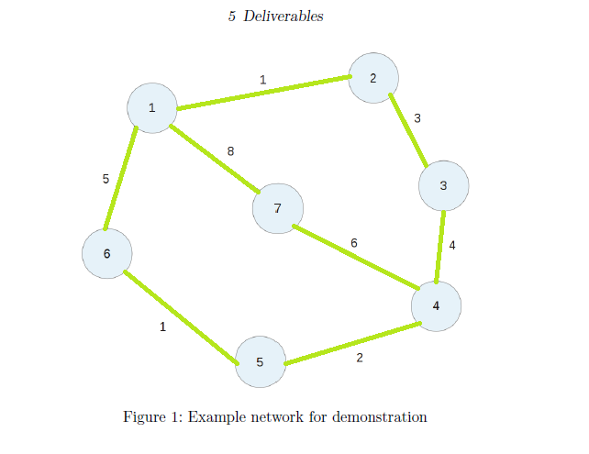

Here is an example of the configuration file of Router 1 used in the project.

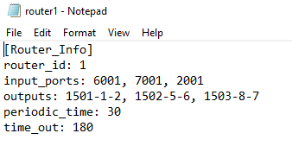

This shows that the RIP Routing Protocol is working well. The design and implementation of the Routing Protocol was successful. All the test cases are passing. Poisoned reverse is working by changing the metric to 16. New routes are also being calculated. Routes with a metric of 16 or more are being ignored. Timeout and garbage timers are working correctly when it comes to timing out and deleting a router. The routing table converges correctly for all Routers. Configuration file tests are handling any errors inside the configuration file before processing whereas the routing tests have all passed.